Assignment 1: Pseudocode and Flowchart for Sorting Algorithm - Write pseudocode and create a flowchart for a bubble sort algorithm. Provide a brief explanation of how the algorithm works and a simple array of integers to demonstrate a dry run of your algorithm.

Begin BubbleSortAlgorithm(Array)

n = length(Array)

repeat until no swaps

swapped = false

for i = 0 to n - 2 do

if Array[i] > Array[i + 1] then

swap(Array[i], Array[i + 1])

swapped = true

end if

end for

n = n - 1

end repeat

return Array

End BubbleSortAlgorithm

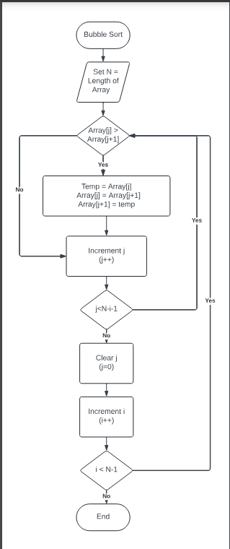

Explanation of the algorithm:

Bubble sort works by repeatedly stepping through the list, comparing each pair of adjacent items, and swapping them if they are in the wrong order.

The algorithm passes through the list multiple times until no swaps are needed, indicating that the list is sorted.

In each pass, the largest unsorted element 'bubbles up' to its correct position.

Array: [5, 3, 8, 1, 2]

Pass 1:

[3, 5, 1, 2, 8]

(swapped 3 and 5)

[3, 1, 2, 5, 8]

(swapped 5 and 1)

[1, 2, 3, 5, 8]

Pass 2:

[1, 2, 3, 5, 8]

(no swaps needed)

Array after sorting: [1, 2, 3, 5, 8]